Behavioural diagrams:

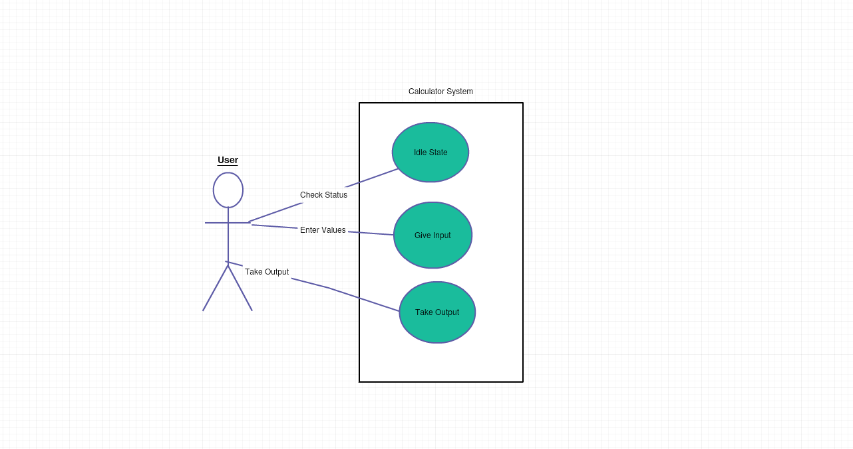

USE CASE DIAGRAM

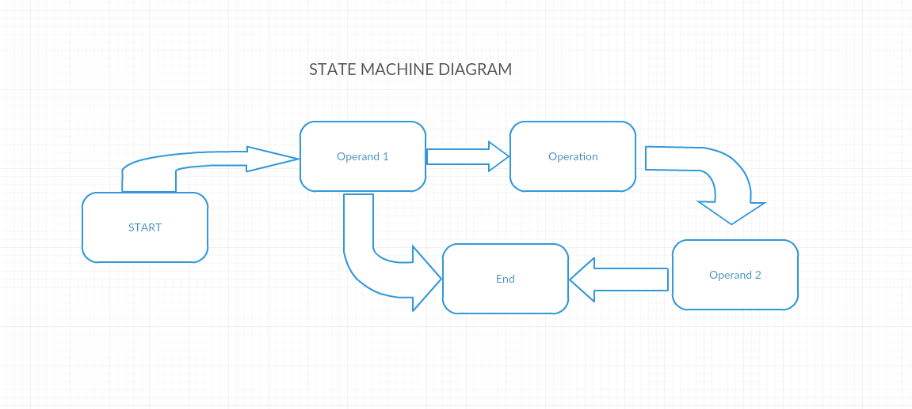

STATE MACHINE DIAGRAM 1